Name:_____________________________________________________________

Geography: Along the Lincoln Highway – United States of American

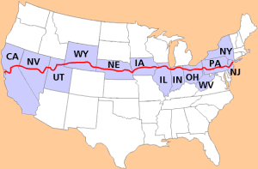

Questions:

1. What are the physical characteristics in geography?

List physical characteristics for each state?

1. What is a human characteristic in geography?

List human characteristics of each state?

1. What is an ecoregion?

Are the two states in different ecoregions?